This access is limited to countries that do not have dedicated link to our corporate network (BT provider).

I- Prerequisites

If you have never used the Tango CoreModel app before, you will need to install on your computer the before starting the connexion to TANGO.
The plug-in “citrix receiver” must be installed.
You can download it from this website:
https://www.citrix.com/downloads/citrix-receiver/windows/receiver-for-windows-latest.html
Exemple:
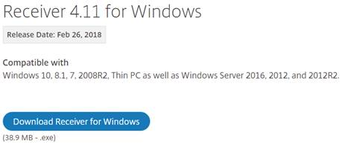
There is no need to configure anything special, just running the setup.

Sometimes, you can have the request below, but it’s not used so you can ignore it.
The email address is not to configure.
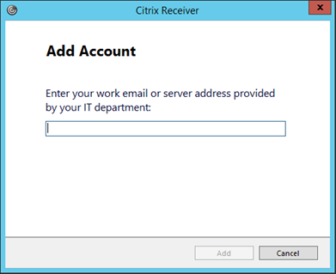

II- Access to TANGO

The link to the new website is: https://www.partenaires.co



Enter your login details in the section below (login / password)
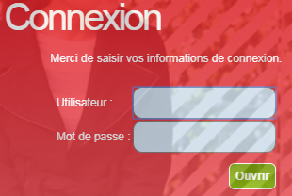

A second identification is needed.
Please re-enter your account and password
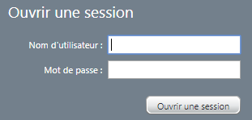

After that, click on the following link
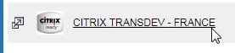

Choose the directory below
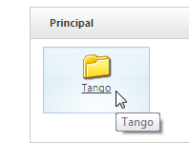

And now, you can access at the TM1/ Perspective application, where Tango Core Model is available.
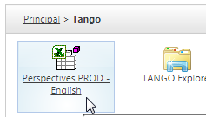

A window for this application will appear a few moments later

